Report on Capacity, Quality, and Accessibility of Veteran Affairs Clinics

in Southern California

Prepared for the Office of Congressman Mark Takano (D-Riverside)

41st Congressional District of California

Derreck Carter-House*, Science to Policy at the University of California, Riverside

January 27, 2020

# Executive Summary

This report describes Southern California veterans, and their needs with regard to Veteran Affairs Health Facilities. US Census Bureau Data including veteran age, disability status, income level, and race is documented. To analyze the quality and ratings of health care, physical addresses were accessed using data from the US Department of Veteran Affairs (VA). Transportation routes, drive-time, and accessibility to these facilities were analyzed using traffic reports and map data from ArcGIS, as well as bus stops from the Riverside Transit Authority. In general, this report finds that, despite having the largest veteran population of any state, California does not have A) high quality medical centers and B) clinics that are easily accessible by much of the population, and that C) this impacts some veteran groups much more than others. VA (SAIL) internal evaluations composed of 25 different metrics, show that the best California facilities have only 3, 2 or 1 star facilities. This is in contrast to the 5 star quality seen on the east coast. An additional issue identified is the need for improved accessibility. Metrics not evaluated by SAIL such as demographics, income, and disabilities clearly show important physical locations where additional facilities should exist to serve these populations. One such location is Congressional District 41. Access to other clinics requires high drive times to clinics (>30 minutes) and bus routes are exceptionally long (>1 hour). This significantly impacts disadvantaged populations in this district especially senior citizens, disabled veterans, and impoverished veterans who need to use these facilities.  There is clear evidence there is a strong need for improved health services for Veterans, that CD 41 is a prime location for a new Veteran Affairs Health Facility and Touchpoints, or urgent care centers run by the VA likely to be effective.

# Methodology:

This report was generated using R v. 3.6.0 (with packages: readxl, ggplot2, and reshape2) and ArcGIS. The scrips for R can be downloaded from Github, <https://github.com/Derreckadam/Takano_fellowship>.

**DATA SOURCES:**

* Traffic Data for ArcGIS can be accessed [here](http://help.arcgis.com/en/arcgisdesktop/10.0/help/index.html#//001z00000003000000.htm)[1]
* Veteran’s Affairs office provided the quality scores for the VA Medical Centers (SAIL) is found [here](https://www.va.gov/QUALITYOFCARE/measure-up/Strategic_Analytics_for_Improvement_and_Learning_SAIL.asp)[2]
* The US Census Bureau provided demographics, income, age, disabilities and veteran status can be found [here](https://www.census.gov/)[3]

# Background

California has the highest population of veterans in the United States, yet the lowest rated Veteran Affair’s medical facilities. **The need for improved quality of care is clear, and an underlying issue is clinic accessibility.**  There are many factors that determine quality of care such as death rate, complications, patient satisfaction, overall efficiency and physician capacity. However, an important but overlooked statistic is accessibility of the clinics. Is the clinic in a physical location where it can meet the needs of the veterans it serves? Accessibility is particularly challenging in California due to the vast geographic area in which healthcare needs to be provided, but also long drive times due to traffic associated with the highly populated areas like Los Angeles. The latest American Community Survey(ACS), 2017 from the US Census Bureau and maps generated by ESRI’s ArcGIS maps and R Statistics Program, and show the need for a VA Medical Facility in Congressional District 41 as high populations of racial minorities are found inland and in desert regions away from most of the current clinic locations.

# History

Veteran’s health care in the US began with the National Home for Disabled Volunteer Soldiers in 1865. After the Civil War, as health care transitioned from home to hospital, 11 facilities were established in the first part of the 20th century. With each major war (World War I and II, Korean War, Vietnam, Kuwait) the increased population of injured veterans led to more facilities. Today the Veterans Health Administration currently oversees 144 VA Medical Centers and 1,232 outpatient sites [[Denkman](https://laist.com/2018/07/10/everything_you_need_to_know_about_the_massive_decaying_west_la_va_campus_--_and_the_plan_to_fix_it.php), [Office of Policy, and Planning](https://www.va.gov/vetdata/), [Radio, Southern California Public.](https://www.scpr.org/news/2018/04/26/82584/the-va-plans-to-move-a-ptsd-clinic-in-west-la-thes/) [“Report Card - Vets Advocacy.”](https://www.vatherightway.org/report-card/)]

In the area surrounding Congressional District 41 there are currently 5 VA clinics operated by the Loma Linda University. These clinics were established in 1977, and in the last 40 years southern California and the city of Riverside have continued to grow. While the desert community populations of Riverside County continue to grow, facilities that handle post-traumatic stress disorder seem to be shrinking or disappearing rather than expanding [“[VA Facility in West Los Angeles Abandons Homeless Veterans - Lawsuit Challenges VA’s Misuse of Land Given to House Injured Vets.](https://www.aclusocal.org/en/press-releases/va-facility-west-los-angeles-abandons-homeless-veterans-lawsuit-challenges-vas-misuse)”, [VA Greater Los Angeles Healthcare System](https://www.losangeles.va.gov/masterplan/)].

Looking forward, as health care changes and adapts, caring for the veteran population should also change. Integrating the use of “touch points” and increased mental health facilities is an important first step. These touchpoints are urgent care facilities operated by the VA that provide services to remote populations that would otherwise be expensive and potentially inaccessible to veterans.

# National Veteran Population

California has about 1.6 million veterans, according to the Census Bureau’s American Community Survey from 2013-2017, making it home to more veterans than any other state. In fact, California has more veterans than 17 other states combined. Figure 1 shows veteran population for each state. Texas and Florida are in second place with about 1.5 million each. However, all other states have less than 100,000.

**Figure 1: Bar graph showing Veteran populations of every state in the US. California has the most veterans of any state.**

Figure 2 shows the US divided into 50 square mile sections. The darker the shade of the tile, the more veterans reside in that subsection of the US. The greatest populations are over 50,000 veterans per 50 square miles, and the lowest populations were less than 100 veterans. Figure 2 shows veterans are residing in high numbers on the west coast, specifically in California.

**Figure 2: 50 square mile blocks show veteran population hotspots on the East Coast and the West Coast**

Despite having the most veterans of any state, the VA facilities in California region do not meet the 5-star standards of the VA as on the East Coast. The highest rating of a VA medical facility on the West Coast is 3 stars, with many 2- and 1-star facilities, Figure 3. The ratings are assessed by the VA and are based on the SAIL algorithm (Strategic Analytics for Improvement and Learning). This survey takes into consideration access to care, quality of mental health care, employee perception about the organization, nursing turnover, efficiency and capacity.

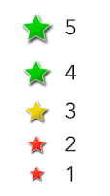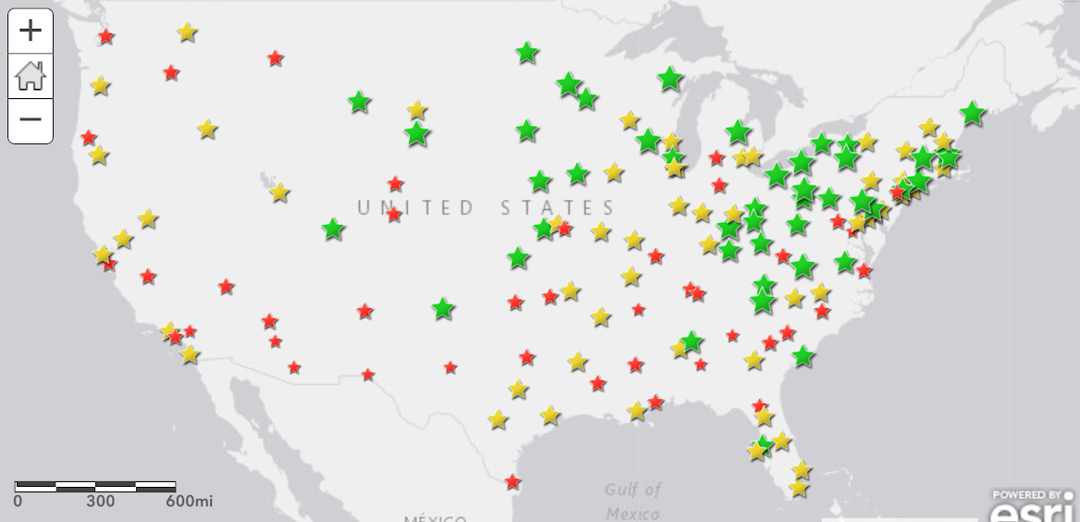

Veteran Affairs SAIL Score

**Figure 3: VA data shows that the quantity and quality of clinics decreases in the western US**

# California Veteran Population

Much of Southern California has very dispersed populations, and much of the veteran population is not on the coast, but eastward towards the desert, as shown in Figure 4. Additionally, the population is all from different branches of the military due to geographic features needed for their operations, such as coastal access for the Navy, or less populated areas for air force bases and training bases. For example, sites near existing training bases may need different facilities than those of retired veterans in the desert regions.  California has a growing population and many people (approximately 2.6 million in the last 10 years) are moving to California everyday [U.S. Census Bureau].

Veterans per 5 square miles

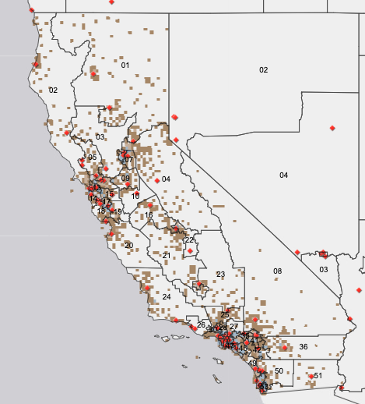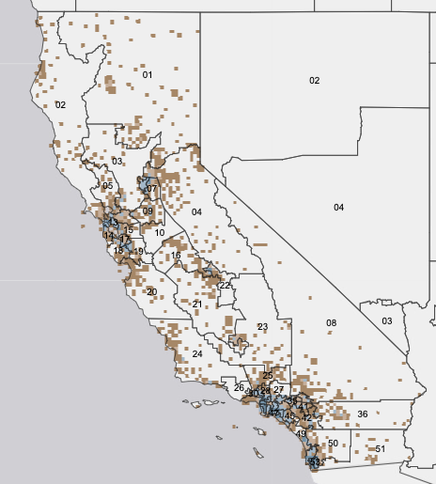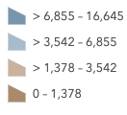

Veterans Affairs Medical Centers



**Figure 4: Veteran populations in Southern California depicted by circular dots of varying shades (higher veteran numbers correspond to darker shades)**

# Southern California Veteran Population

Veterans

Nearly 1 million veterans reside in Southern California Congressional districts (CD) 8 and 23 through 53, shown in figure 5. Thirty thousand veterans call CD 41 home, however there is no VA clinic in CD 41(shown in Figure 5). The nearest one, in Corona, is about a two-hour regional transit (bus) ride, from the center of CD 41.

In addition to poor access for the city of Riverside veterans, demographics show that Hispanic/Latino and Black/African American populations are also underserved.

Veteran Facilities

Veterans Affairs Medical Centers

**Figure 5: Current United States Congressional districts**

Figure 6 shows a magnified view of Southern California and highlights that much of the veteran population is found in cities surrounding LA or in the desert (as denoted by dark dots) and these population “hot spots” do not always align with VA clinics. For example, CD 41 has a high population of veterans but no clinics. The issue with clinics located in areas where only White affluent populations can afford to live means that marginalized races and veterans who cannot afford coastal property must commute by public transport or by car on congested freeways for great distances.

Veterans

Veterans Affairs Medical Centers

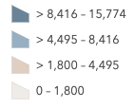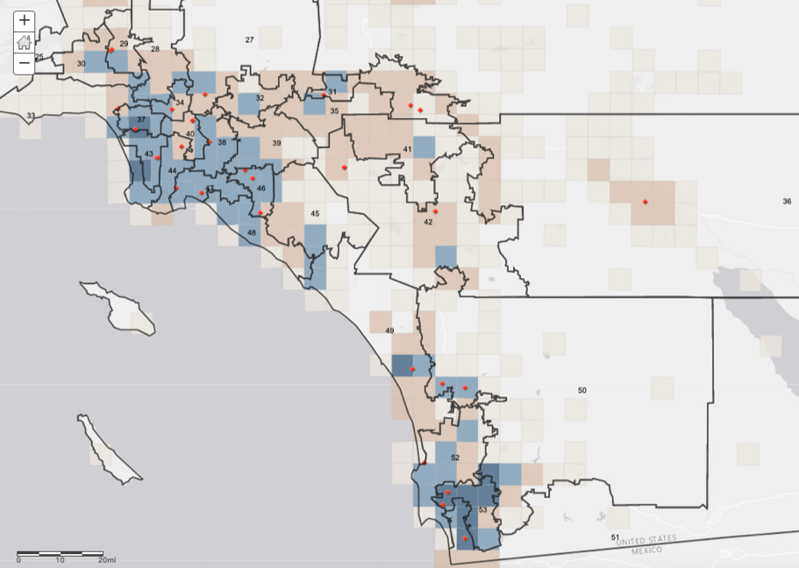

**Figure 6: Veteran populations are found high concentrations in eastern CDs not along the coast.**

### Transportation to VA Medical Facilities in Southern California

Veterans who are not within walking/public transport distance must be able to drive or find someone to drive them to a clinic. Los Angeles traffic creates issues for veterans trying to make early morning appointments or departing for home later in the day. Figure 7 shows a computational analysis of streets that can be reached from the VA facilities in given intervals of time. It is a snapshot time-to-clinic based on typical Monday traffic at 12:00pm. VA medical facilities in Southern California serve as the starting/reference points, with concentric drivable distances within increasing timeframes (10min, 20min, 45min, and 1hr). For example, green-shaded areas highlight 10-minute drive-times to VA facilities.

The data show that there are many veterans who must spend over an hour driving in a car to a clinic. In high traffic conditions these times may even be higher. This is even more pronounced for veterans not residing in Los Angeles. CD 41 has 20-30 minute drive by car. Additionally, CD 41 is surrounded by mountains which requires constituents to drive around the basin through a pass in the west to get to facilities, Figure 7b.

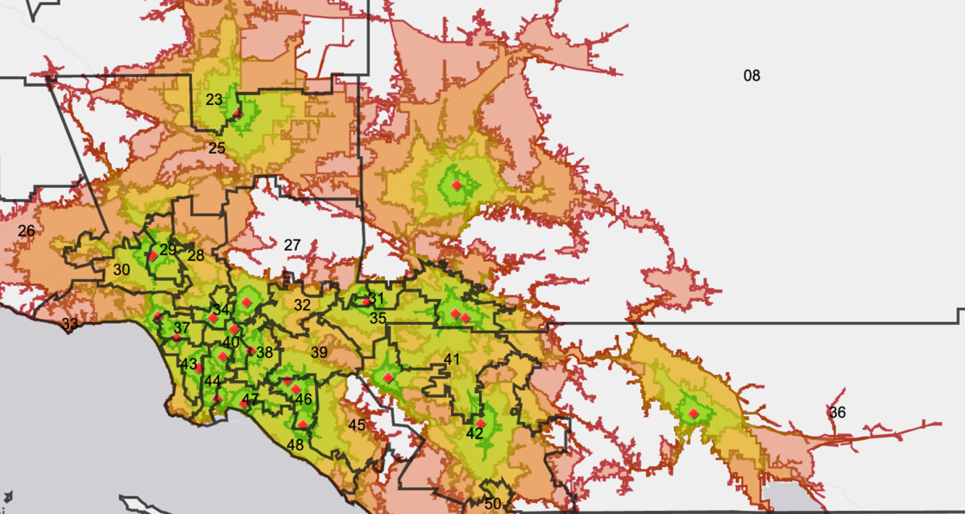

Drive Times Up to:

10 Minutes

Drive legend

60 Minutes

45 Minutes

30 Minutes

20 Minutes

**Figure 7: Drive times to VA health facilities.**

Drive legend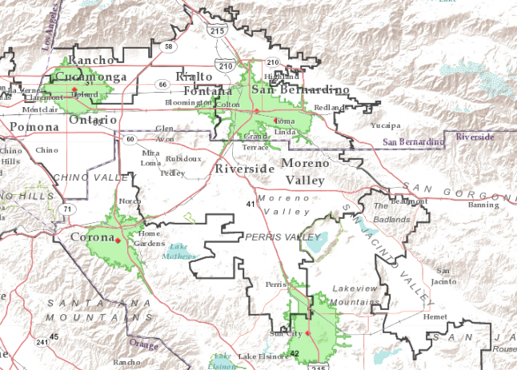

Veterans Affairs Medical Centers



Drive Times Up to 10 Minutes

**Figure 7b: CD 41 is situated in a mountain basin.**

### 

### Race

The following heatmap (Figure 8) shows various races self-identified by veterans in census data within CDs. The darker the tile the higher the population of the given race in the CD (CDs 29-34 have increased population levels of races other than “White”).

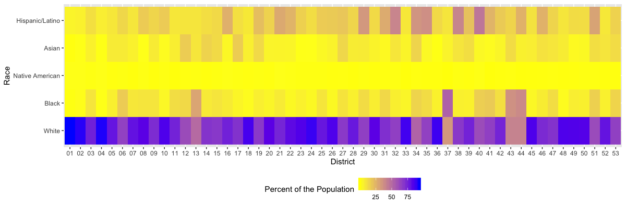

**Figure 8: Heatmap of demographic populations of veterans in all California CDs**

Southern California is predominantly White (50% or greater of the population), however, there are some areas with predominately minority populations. These can be visualized spatially, giving better insight into the relationship of clinic locations and high population densities of demographic groups (Figure 9). The dots in the following maps show percent population of each demographic group living in that assigned census tract. A census tract is one of the smallest geographical features monitored by the US Census Bureau and contains approximately 4,000 individuals.

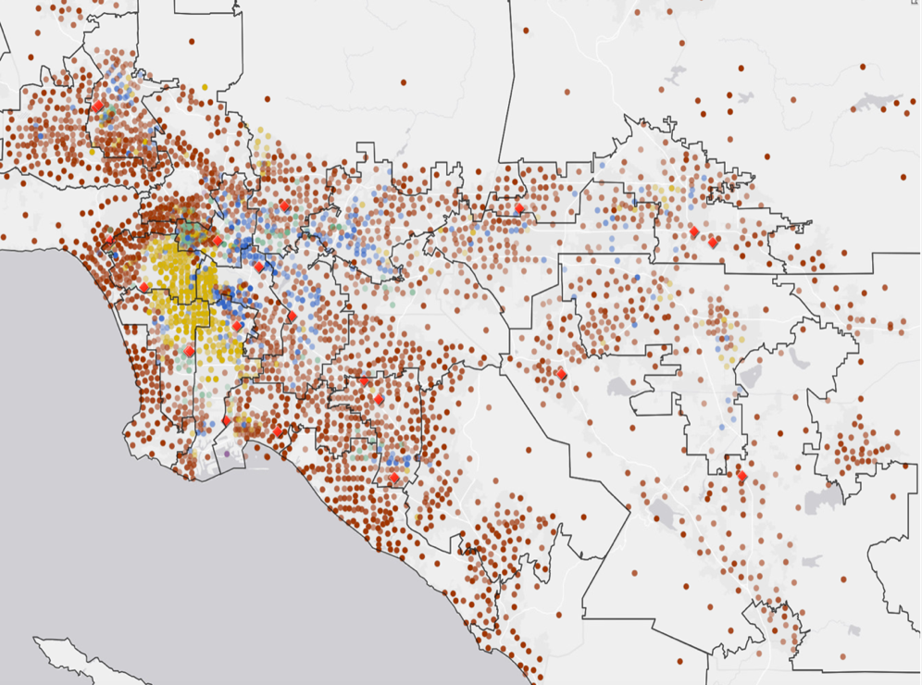

White

Black/African American

Hispanic/Latino

Asian

Native American

Predominant Category:

Veterans Affairs Medical Center



**Figure 9: Dots indicated predominant race in the respective geographic location (US census tract)**

Furthermore, by examining races individually, areas where clinics are needed become more apparent. The data in the following figures shows that clinic locations are not found in densely populated areas of African/African American or Hispanic/Latino populations. Clinic locations are more closely located to high White and Asian populations.

African American and Black populations dominate tracts found mostly in inner-city Los Angeles. Clinic locations are mostly located outside of the inner city area, Figure 10A. While the clinics are not placed in the heart of predominately (over 63% of veterans) African American/Black areas, they are still located in the city and can be reached by public transport. Another large population of African American/Black individuals reside in CD 41, Figure 10B. These populations have less access to clinics due to increased public transport times. For example, a Moreno Valley resident leaving at 9:00AM would need to take two bus lines (RTA line [16 and 14](https://www.riversidetransit.com/index.php/route-info)) for a total of approximately 40 stops to Redlands, CA, anticipated travel time would be approximately 1.5 hours, or 3 hours round trip.

Many Hispanic/Latino populations are in Riverside and the San Bernardino mountains (CDs 32, 35) where there are no clinics, demonstrated in Figure 10C. Figure 10D shows there are no VA medical clinics in CD 35 and 41 but many census tracts with 30% to over 70% Hispanic communities. Additionally, Native American populations are dispersed throughout Southern California, Figure 10E, with some of the highest concentrated tracts (4% of the overall veteran population) located in CD 41.

As a baseline reference, White populations (similar to Asian populations) have highest density in areas where VA clinics are located, Figure 10F and G.

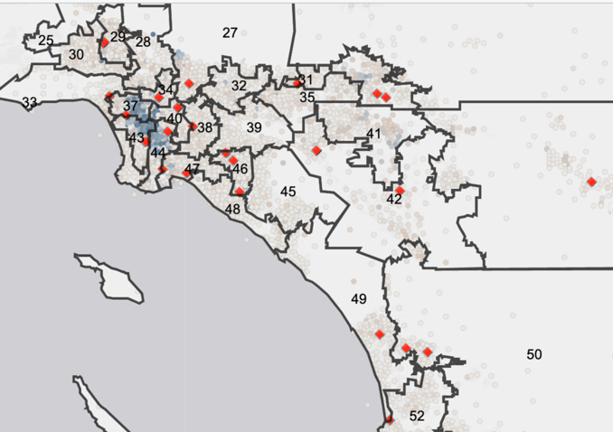 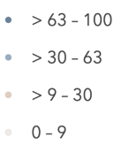

Veterans Affairs Medical Centers



Percent African American/Black Veterans

A

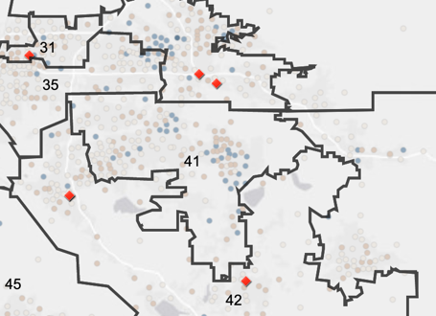 

Veterans Affairs Medical Centers



Percent African American/Black Veterans

B

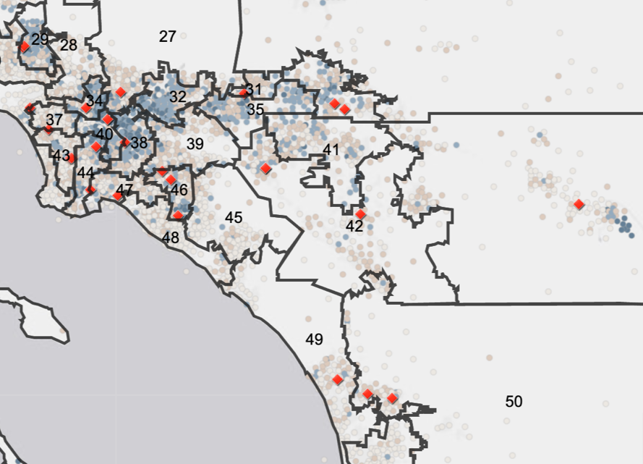 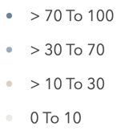

Veterans Affairs Medical Centers



Percent Latino/Hispanic Veterans

C

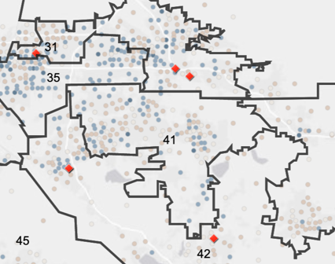 

Veterans Affairs Medical Centers



Percent Latino/Hispanic Veterans

D

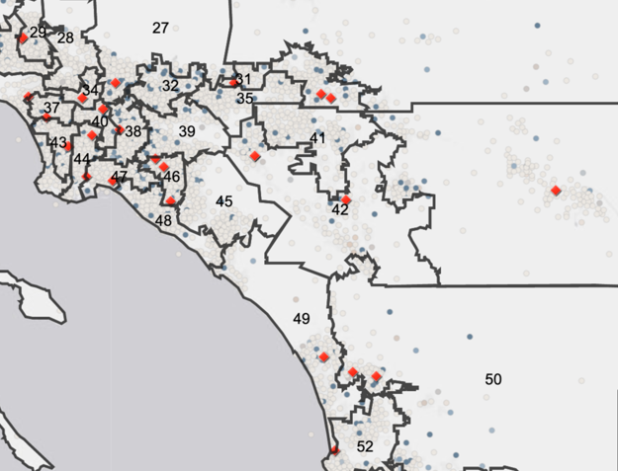 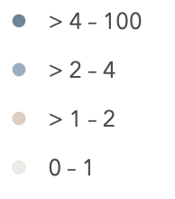

Veterans Affairs Medical Centers



Percent Native American Veterans

E

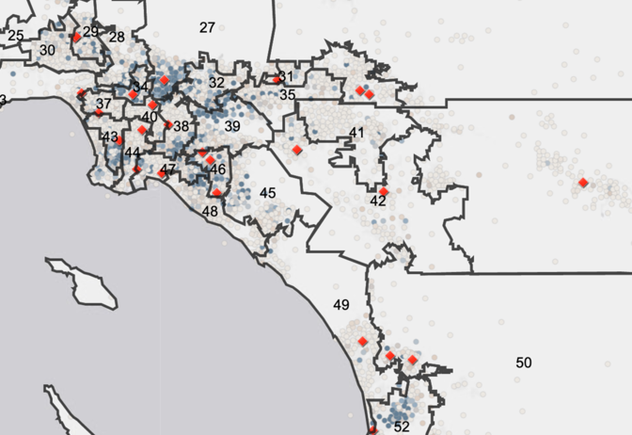 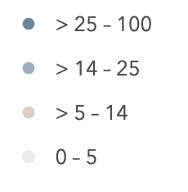

Percent Asian Veterans

Veterans Affairs Medical Centers



F

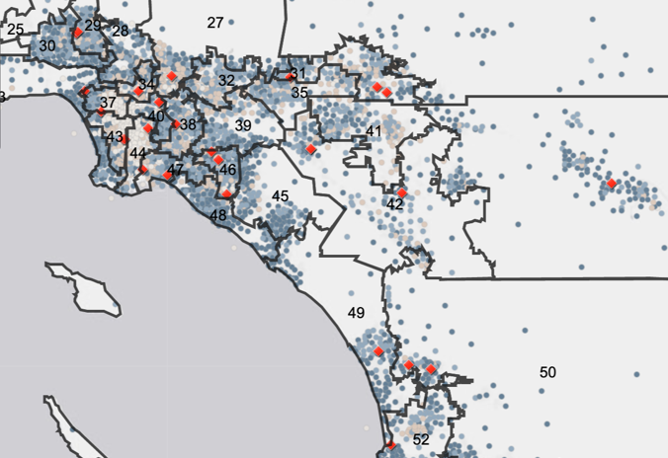 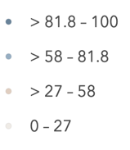

Veterans Affairs Medical Centers



Percent White Veterans

G

**Figure 10 A-G: Dots indicate percent population of given race in US Census tract**

## Need for Transportation to Make Clinics More Accessible

There are approximately 60,000 disabled vets in CD 41 and surrounding CDs. Surrounding CDs were determined by having a less than 10-mile proximity to CD 41. The following is a breakdown of veterans with disabilities, senior status, and those living below the poverty line that might inhibit them from being able to drive a car.

### Disabilities

An evaluation by the VA ranks a disability (for example hearing loss) with its association to combat service and the amount of impact it has on the veteran’s day to day life. A higher “service-connected disability” rating (SCDR)means a greater degree of severity. A service-connected disability that is 0% means that the diagnosed condition was due to service but does not impact daily life. CD 41 has many (approximately 30,000) disabled veterans. Figure 11 shows that CD 41 has comparable disabled veteran numbers to other surrounding CDs. Having a diagnosed disability, especially those recognized by the VA to be 70% or higher SCDR, can significantly increase the difficulty associated with visiting a clinic.

**Figure 11: Bar graph showing veteran service-connected disability by severity. Each Southern California CD is denoted with a unique color to show the total number of veterans in each category.**

### Senior Status

The detrimental effects of aging can reduce veterans’ independence making getting to a clinic more difficult. Additionally, increased age increases the need for clinics. Fifty percent of the veteran population in California is 65 years or older. Age is a very important category for VA facilities to consider, yet many populations of seniors in CD 41, 32, 39, and 45 are not near VA facility locations (Figure 12 and 13). In general, the senior veteran populations are dispersed. However, there is a high population of seniors in CD 36 (Eastern California) with access to only one clinic.

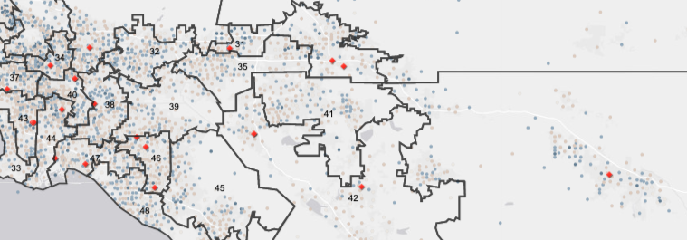

36

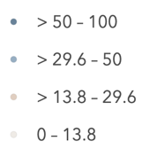

Percent 65 to 75 Year-Old Veterans

Veterans Affairs Medical Centers



**Figure 12: Dots represent census tracts with percentages of veterans 65 to 75 years old.**

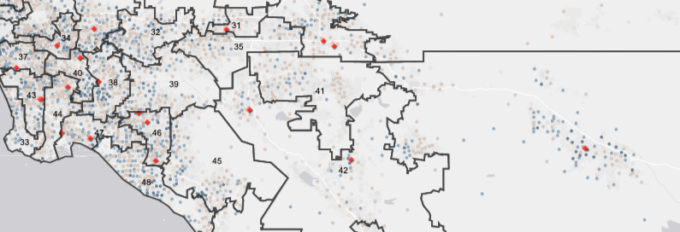

36

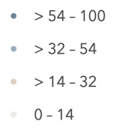

Percent 75+ Year-Old Veterans

Veterans Affairs Medical Centers



**Figure 13: Dots represent census tracts with percentages of veterans over 75 years old.**

### Income

Living below the poverty line makes accessibility to a clinic increasingly difficult, due to factors like the reliance on public transportation or accommodating busy work schedules of caregivers. About 10% of veterans are living below poverty in California, according to ACS 2017 one year estimates. Figure 14 shows areas in Southern California with high population (over 48%) of the census tract that contains impoverished veterans.

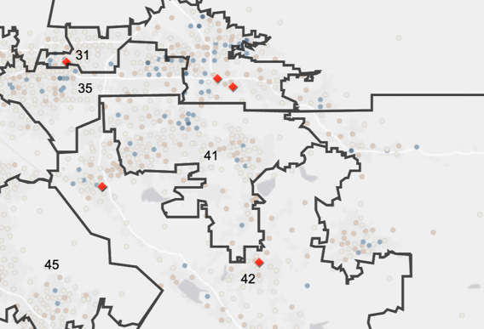 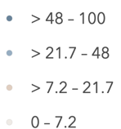

Veterans Affairs Medical Centers



Percent Veterans Living Below Poverty

**Figure 14: Dots represent census tracts with percent veteran populations living below poverty.**

# Conclusion

While western areas have many clinics, veterans are located further east in places, such as CD 41, making it a prime location for a Veteran Affairs Health Facility. While the data show high populations of disadvantaged (disabled, seniors, impoverished) veterans and racial minority (Hispanic/Latino and Black/African American) that call CD 41 home, other factors such as the veteran student populations at the University of California, Riverside Community College, La Sierra University, California Baptist University and that CD 41 is a major junction point for California routes 91 and 215 should be considered.

In addition to the need for a VA clinic in CD 41, the dispersed population of veterans that reside in eastern California, specifically CD 8 and CD 36 need facilities. Touchpoints, or urgent care centers run by the VA likely will prove to be an effective method. However, further work must be done to research the desert populations and their specific needs.

**Sources**

Denkmann, Libby. n.d. “Everything You Need To Know About The Massive, Decaying West LA VA Campus — And The Plan To Fix It.” LAist. Accessed August 20, 2019. <https://laist.com/2018/07/10/everything_you_need_to_know_about_the_massive_decaying_west_la_va_campus_--_and_the_plan_to_fix_it.php>.

Office of Policy, and Planning. n.d. “National Center for Veterans Analysis and Statistics.” Accessed August 20, 2019. <https://www.va.gov/vetdata/>.

Radio, Southern California Public. 2018a. “The VA Wants to Move a PTSD Clinic. The Vets Are Fighting Back.” Southern California Public Radio. April 26, 2018. <https://www.scpr.org/news/2018/04/26/82584/the-va-plans-to-move-a-ptsd-clinic-in-west-la-thes/>.

“Report Card - Vets Advocacy.” n.d. Vets Advocacy. Accessed August 20, 2019. <https://www.vatherightway.org/report-card/>.

U.S. Census Bureau. 2017. “American FactFinder,” October. <https://factfinder.census.gov/faces/nav/jsf/pages/index.xhtml>.

“VA Facility in West Los Angeles Abandons Homeless Veterans - Lawsuit Challenges VA’s Misuse of Land Given to House Injured Vets.” 2011. ACLU of Southern California. June 8, 2011. <https://www.aclusocal.org/en/press-releases/va-facility-west-los-angeles-abandons-homeless-veterans-lawsuit-challenges-vas-misuse>.

VA Greater Los Angeles Healthcare System, U.S. Department of Veterans Affairs. n.d. “Master Plan to Revitalize West LA Campus - VA Greater Los Angeles Healthcare System.” Accessed August 20, 2019. <https://www.losangeles.va.gov/masterplan/>.

1. <http://help.arcgis.com/en/arcgisdesktop/10.0/help/index.html#//001z00000003000000.htm>
2. <https://www.va.gov/QUALITYOFCARE/measure-up/Strategic_Analytics_for_Improvement_and_Learning_SAIL.asp>
3. <https://www.census.gov/>